International Freephone Services
Process for Conversion to Colt Standard Freephone and Porting
The International Freephone Service enables a customer in one country to be allocated (through his local carrier) a Freephone number in another country, which allows callers in that country to call the customer free of charge.
Colt DOES NOT OFFER AN INTERNATIONAL FREEPHONE SERVICE (IFS), however under most circumstances we are able to convert existing IFS number to a normal national freephone number and port them to Colt. This allows the customer to retain the number, and operate a Freephone service in a chosen originating country, but the number loses its International Freephone characteristics.
There is no established process between European carriers for conversion and porting of IFS numbers. As such, IFS conversion and portability must be considered on a case by case basis. The table below summarises our experience to date with the conversion and porting of IFS numbers by Colt country.
Colt Country | Feasibility of IFS Conversion and Porting | Process to follow
Netherlands | Feasible as BAU | Standard porting processes
Spain
Belgium
France
Germany
Italy
Ireland
Switzerland
UK
Austria | Not feasible – as at 18 June 2013 all previous efforts have not succeeded | No process available
Denmark
Portugal
Sweden

Top level process summary:
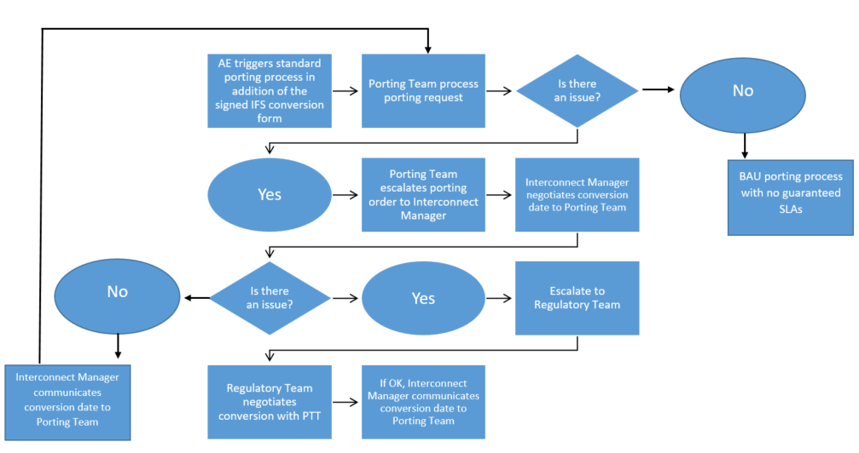
In Belgium, France, Germany, Italy, Ireland, Switzerland and the UK, Account Executives may request conversion and porting of IFS numbers. Note that conversion and porting is not guaranteed.
Step 1: To trigger the process, AE’s must complete and forward the request template and the customer consent form to the porting team (see contact list below). If there are issues then these can be escalated to the interconnect managers.
IFS Number Conversion and Porting Request Template
Customer Name
Contact Address
Number / Range Details
Country
Signed customer consent form

Step 2: The interconnect manager will engage with the PTT commercial manager to negotiate conversion of the IFS number to a standard national freephone number. If successful, the Interconnect Manager will inform the Colt porting team of the conversion date. If discussions with the PTT are unsuccessful, the Interconnect manager will engage / escalate to the Regulatory team.
Step 3: When successful, the porting team communicates the conversion date with the customer, and triggers the standard porting process to occur after the conversion date. See here for user guides for the standard porting and order processes

Country | Porting Contacts
AT | Please find country specific contacts in the ‘Country Porting Contacts’ in the ‘Internal Resources’ section on the Porting intranet page.
BE
CH
DE
DK
ES
FR
NL
IE
IT
PT
SE
UK

Escalation Matrix
Country | Interconnect Managers | Regulatory
AT | Klaus Geese | Christian Weber
BE | Bernard Bierhaus | Jan Degraeuwe
CH | Klaus Geese | Christian Weber
DE | Gerd Schmidt | Christian Weber
DK | Andreas Hindenburg | Ulf Wahlof
ES | Carmen Iglesias | Pablo Diez
FR | Stephane Viard | Emmanuel Tricaud
NL | Bernard Bierhaus | Ellen Koopmans
IE | Richard Anderson | Ceri Owen
IT | Fausto Pisoni | Giulio Brunelli
PT | Carmen Iglesias | Pablo Diez
SE | Andreas Hindenburg | Ulf Wahlof
UK | Richard Anderson | Ceri Owen

