Colt Wholesale SIP (Number Hosting) 8th Nov 2025 Release Notes

Introduction
This document describes the Colt Wholesale SIP (Number Hosting) 8th Nov 2025 release.
The release will focus on:-
- Address Management & Directory Service in Denmark
- Introduction of Digital Letters Of Authorisation for porting in IT, ES and BE
- NOD and B2B API improvements
- New REST APIs
These changes might imply development at your end, so please read this document carefully.
The changes in this release require your support during our test period. The Customer UAT is planned from 22nd Sept 2025 to 10th Oct 2025. Please get in touch with NumberHostingUATSupportTeam@COLT.NET if you would like to participate in the UAT.

Document change control
Version | Change description
V1 | 8th Nov 2025 Release note

Address Management & Directory Services in Denmark

To ensure regulatory compliance in Denmark, important changes relating to address management and validation, and directory services will be implemented as follows:
- New fields will be added for DK and are marked as ‘New’ in the table below. Some validation of existing fields will also be updated. Fields which are changing are marked ‘Update’. Other fields are marked as ‘Remove’.
- Update EDB address and Directory Service Update are clubbed together in an End-customer Address Update
- Final address verification and validation will be performed with Informatica Address Doctor v4
All changes are applicable in Denmark (DK) for number Activation, new Port-In & Address Update operations. The fields are described in the table below:
Element | Description | Change | Current Type | Current Length | Updated Type | Updated Length | Customer Action
End customer Name and details
endCustomerName | It is the end customer name to whom numbers will be activated. | Update | M | L ≤ 80 | M | L ≤ 100 | Length increased to 100
Subscriber ID/ companyRegistrationNumber | (port-in only)  Also known as Organization number / Company Registration Number | No change | M | L ≤ 14 | - | - | -
buildingName | Name of the building | Remove | CM | L ≤ 50 | - | - | Field removed
premisesNumber/ houseNumber | Number of the building | Update | CM | L ≤ 20 | O | L ≤ 11 | Field is optional  Length decreased to 11  <pattern value="([1-9]|[1-9][0-9]|[1-9][0-9]{2})|([1-9][AZ]|[1-9][0-9][AZ]|[1-9][0-9]{2}[AZ])" />  e.g. 001, 001A, 133, 133X, etc.
streetName | Name of the street | Update | M | L ≤ 50 | M | L ≤ 40 | Length decreased to 40
cityTown | Name of the Town. | Update | M | L ≤ 50 | M | L ≤ 20 | Length decreased to 20
postalZipCode | postalCode | No change | M | L = 4 | - | - | Only Numeric characters allowed
floorSuite | Floor number or reference | New | - | - | O | L ≤ 2 | <pattern value="[1-9]|[1-9][0-9]|KL|ST|kl|st|k[2-9]|K[2-9]" />  e.g. 1, 12, k2, K5, KL, ST, kl, st, etc.
doorNumber | Door number | New | - | - | O | L ≤ 4 | e.g. 0012, 1234, 0123,1100,0001, A,B, A-01,th,tv,P2,mf,tv15, C-29 etc.
addressID | Either the complete address or addressID is required in the request | New | - | - | CM | L ≤ 20 | Either the complete address or addressID is required in the request
Directory services update (Mandatory Node)
Parent Start telephone Number | Conditional Mandatory with order level. startFullNumber and endFullNumber with multiple number ranges or multiple individual CLIs are provided if operation type is Activation and Portin Activation. | New | - | - | M | L =11 | Allowed pattern: +{country code}{phone number without leading zero}
Parent End Telephone Number |  | New | - | - | M | L =11 | Allowed pattern: +{country code}{phone number without leading zero}
Secret or Omitted Marking / secretOmittedMarking | Indicates whether the subscriber has requested for the number and/or address to be listed or unlisted. | New | - | - | M | LOV | List of values:  - NotSecret (By Default)  - Omitted  - NumberSecret  - AddressSecret
Consent for Further Use/  furtherUsageConsentIndicator | Indicates whether the end user has expressly given consent to further use of information. | New | - | - | CM | LOV | List of values:  - Consented  - Not Consented  If "secretOmittedMarking" value is "NotSecret" then furtherUsageConsentIndicator field can take value of "Consented" or "Not Consented".  If "secretOmittedMarking" value is either "Omitted" or "NumberSecret" or "AddressSecret" then furtherUsageConsentIndicator is NOT applicable and no value should be sent.  If user provides ‘Consented’ or ‘Not Consented’, an error will be thrown
Consent Text for Further Use/ furtherUsageConsentText | To the extent that the end user has expressly given consent to the further use of information, the use is indicated. | New | - | - | CM | L ≤ 200 | If ‘furtherUsageConsentIndicator’ field value is ‘Consented’ then Mandatory, else it is Optional.

Digital LOA (IT, ES, BE)
We are extending the countries in which we support a new optional Digital Letter of Authorization (DLOA) in this release to Belgium, Italy & Spain. The DLOA is an electronic version of the traditional Letter of Authorization for port in requests and will allow your end customer to electronically sign the LOA using Docusign.
The DLOA is generated based on the information provided by you in the port-in order raised in our Numbers on Demand portal or over API. We will then generate the DLOA with the information you have populated in the order and send it to your end customer who must then sign it digitally. The signed DLOA will then be stored against the port in order for future reference.
This functionality is optional. If you have your own DLOA functionality then you can opt not to use this feature and to manually upload your end-customer’s LOA in our port-in order.
The benefits of using the DLOA are:
1. Increased Efficiency
- Faster Processing: DLOAs can be created, sent, and signed instantly, cutting down the delays associated with manual workflows
- Automated solution: Easily integrates into digital workflows and systems
2. Improved Accuracy
- Template Standardization: Reduces errors by using a standardized digital form.
- Quick Validation: required fields are validated in real time
3. Enhanced Security
- Digital Signatures: Ensures authenticity and integrity of the document using DocuSign secure digital envelopes.
4. Convenience
- Remote Access: Stakeholders can authorise from anywhere, without the need to print, sign, and scan documents
- Device Compatibility: Can be signed on computers, tablets, or smartphones
5. Cost Savings
- Reduced Paper and Printing Costs: Eliminates the need for physical documents.
- Lower Administrative Overhead: Less time spent on document management and mailing logistics.

Current Port-In process / manual journey – no change
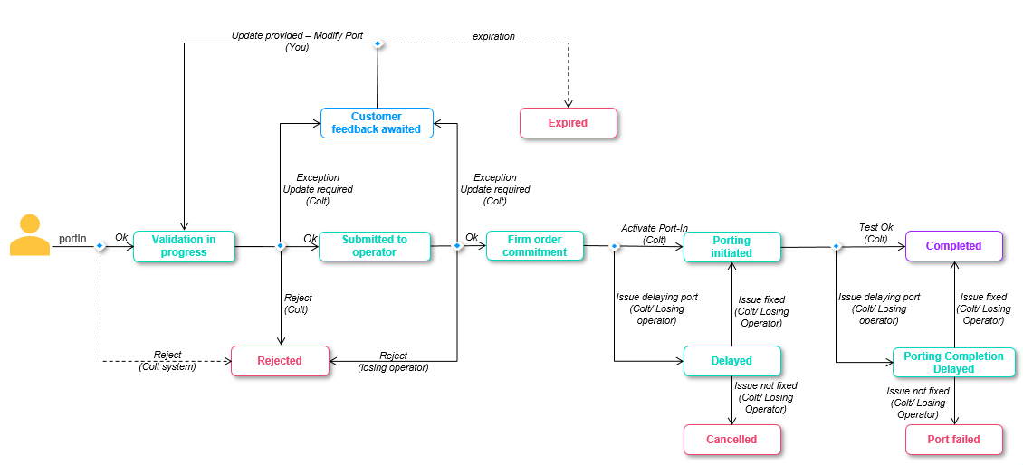

New DLOA Port-In process
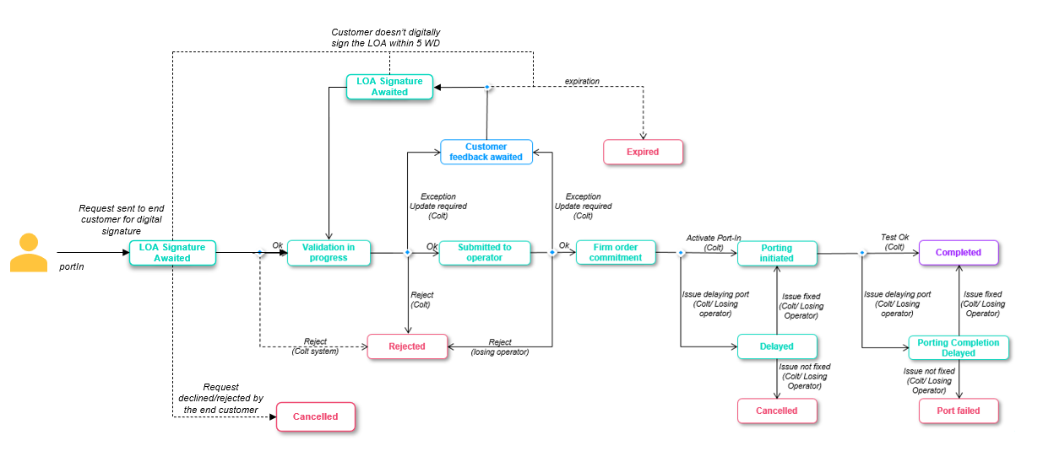
When you submit the portIn request using NOD/API with DLOA as ‘True’ then
  - The request will move to ‘LOA Signature Awaited’ status
    - callBack API notifications, order details screen/API will be enabled with this new status
  - Your end customer will receive the port-in request for digital signature, using the end-customer’s email ID you provide in the port-in order.
The DLOA must be signed within 5 working days otherwise it will expire
  - If signed successfully, Colt will move the order to ‘Validation In progress’ status and our porting desk will receive the order for validation.
    - You will be notified by email (and by callBack if in use) regarding this
    - We will automatically update the porting date if we see that the porting date no longer adheres to the porting lead time (e.g. if the end customer is taking time to sign the DLOA) and you’ll find the details in the email notification and order details.
  - If the DLOA is not signed by the end customer and the link expires after 5 days, then the port-in order will move to ‘Expired’ status.
    - You will be notified by email (and by callBack if in use) regarding this
  - An end customer can also decline/reject the DLOA signature request from their end. In this case the port-in order will move to ‘Cancelled’ status.
    - You will be notified by email (and by callBack if in use) regarding this
  - The Porting Desk can put the order into ‘Customer Feedback Awaited’ status like today to get more details from you. If you update the telephone number (Add new numbers, modify/remove existing numbers) in the ‘Modify Port’ request, the request will again go to your end customer for DLOA signature and the order status will be ‘LOA Signature Awaited’.

DLOA email and link
Email Link Expiry: Links in email notifications will expire after 48 hours or more than 5 consecutive clicks.
If a link expires, the signing authority gets an option to ‘Send New Link’. The Signing authority will receive a new email with a new link.
DLOA expiry: The DLOA will expire after 5 working days for BE and ES and 2 working days for IT after being sent to the signing authority. If the DLOA is not actioned by the customer within 5 working days, the order will be ‘Expired’ in the system and the DLOA will also expire. Post document expiry it cannot be viewed or signed by the signing authority.
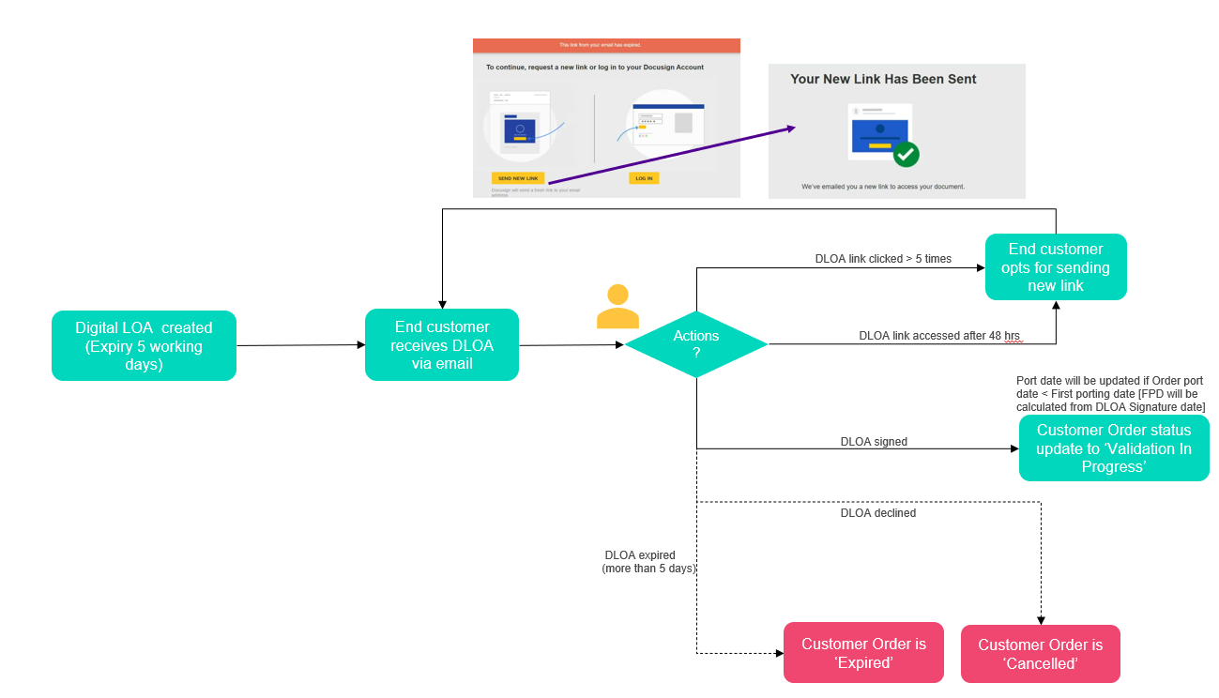

Sample emails
DLOA Signature:
- Email to reseller-
Subject line: Porting Letter of Authorization - Order ID : {orderId}
Email content:
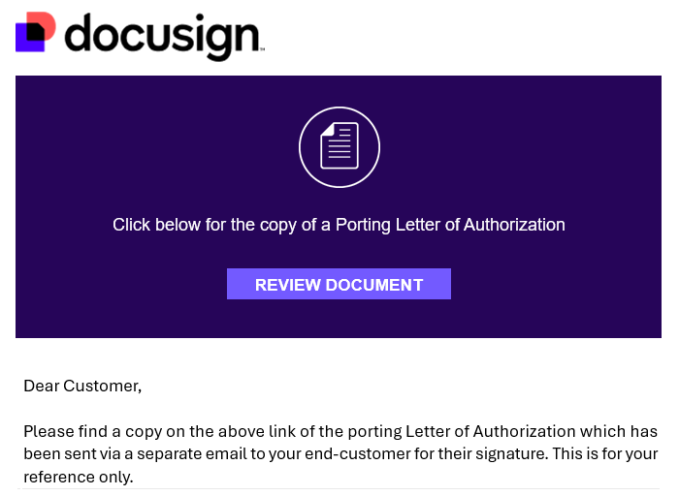
- Email to end customer-
Subject line: Porting Letter of Authorization - Order ID : {orderId}
Email content:
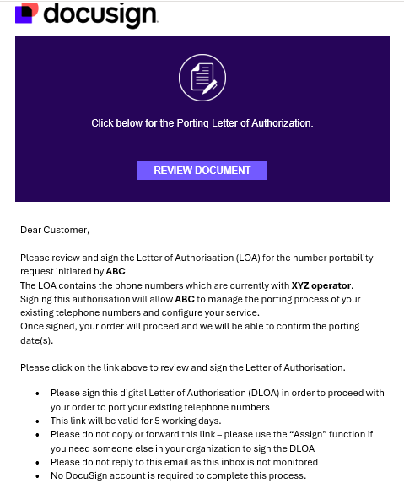

DLOA successfully signed by the end customer
- Email to reseller and end customer-
Subject line: Completed: Porting Letter of Authorization - Order ID : {orderId}
Email content:
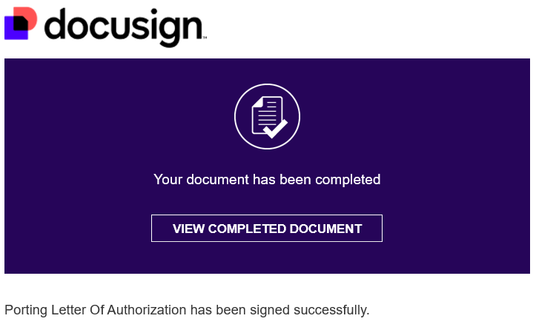

DLOA declined by the end customer
- Email to reseller and end customer-
Subject line: Declined: Porting Letter of Authorization - Order ID : {orderId}
Email content:
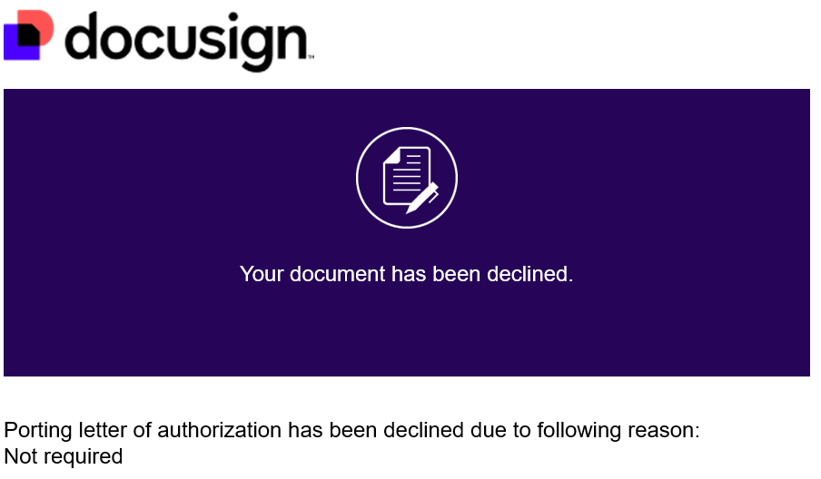

DLOA link expired after 5 working days
- Email to reseller and end customer-
Subject line: Voided: Porting Letter of Authorization - Order ID : {orderId}
Email content:
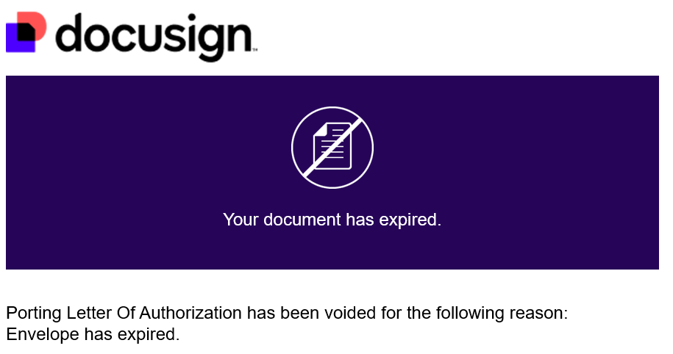

NOD and API impacts:

The DLOA is an optional feature. You have an option to continue with the manual process or opt for the new DLOA journey.
Impacted Functionality:
- NOD: Port -in, Modify Port and Bulk Port In
- new Apigee APIs: POST/v1/portIn/order and POST/v1/portUpdate/order
Please note that DLOA feature will not be available for existing SOAP/HTTPS and REST portIn APIs. There are no mandatory changes which impact you if you are using the existing SOAP/HTTPS and REST portIn APIs.

BE (Belgium)

Field level details:
Fields/sections | Impact | Manual Journey | DLOA Journey
Digital LOA / digitalLetterOfAuthorityFlag | New Optional field  NOD: Digital LOA  Tick box  (Default: Unticked/ Manual)  Apigee API: digitalLetterOfAuthorityFlag  Allowed values: True, False (Default) | If the flag is not ticked on NOD or no value/ ‘False’ is sent in the API request, then the existing manual process will continue. | If the flag is ticked or the value is sent as ‘True’ in the API request, the DLOA journey will be initiated.
Customer Type (Business or Residential)  Customer Language (DE, FR, EN, NL) | No Change | Mandatory | Mandatory
Customer Type= Business: Customer Name/ endCustomerName  Customer Type= Residential:  First Name + Last Name / (firstName + lastName) | No Change | Mandatory | Mandatory
Company Registration Number / companyRegistrationNumber | No Change | Optional | Optional
End Customer current address | No Change | Mandatory | Mandatory
End Customer new address | No Change | Optional | Optional
Telephone Numbers | No Change  max 25 single numbers/ ranges | Mandatory | Mandatory
autoPortIn | No Change | Optional | Optional
Main Billing Number (MBN) | No Change | Mandatory at range level | Mandatory at range level
Single or Multi Line | No Change | Optional | Optional
Letter of Authorization | No Change for manual journey  Not required for DLOA journey as it will be auto-generated and sent to the end-customer via Docusign | Mandatory | Not applicable
Invoice Document/ Supplementary Form | No Change | Optional | Optional
Porting Date | No Change | Mandatory | Mandatory
Porting Window | No Change | Mandatory | Mandatory
Current Operator | No Change  NOD: Current Operator  Apigee API: currentOperator  To check the correct operator for any number please visit: www.crdc.be | Mandatory | Mandatory
Porting Contact details (port update notifications are sent to the email address present in this section) | No Change | Optional | Optional
Digital LOA details / signatoryDetails  (your end-customer will receive the DLOA for signature via DocuSign - the email ID must be of the end-customer’s signatory because the docusign email cannot be forwarded on by the end-customer) | Mandatory for DLOA journey  Sender details (you will be the sender of the email triggered to the end customer and the details provided below are what your end-customer will see. This is an optional node- if not provided, it will automatically fetch sender details from Colt’s database)  NOD: Your Company Name (M) and your Email Address (M)  Apigee API: senderCompanyName (M), senderEmail (M)  Recipient/Signing Authority details (your end customer who will receive the LOA for digital signature)  NOD: First Name (M), Last Name (M), Email Address (M)  Apigee API: signingAuthorityFirstName (M), signingAuthorityLastName (M), signingAuthorityEmail (M) | Not applicable | Mandatory
Customer Reference | No Change | Optional | Optional

ES (Spain)

Field level details:
Fields/sections | Impact | Manual Journey | DLOA Journey
Digital LOA / digitalLetterOfAuthorityFlag | New Optional field  NOD: Digital LOA  Tick box  (Default: Unticked/ Manual)  Apigee API: digitalLetterOfAuthorityFlag  Allowed values: True, False (Default) | If the flag is not ticked on NOD or no value/ ‘False’ is sent in the API request, then the existing manual process will continue. | If the flag is ticked or the value is sent as ‘True’ in the API request, the DLOA journey will be initiated.
Customer Name/ endCustomerName | No Change | Mandatory | Mandatory
Company Registration Number / companyRegistrationNumber (CIF/NIF) | No Change  Required if an end customer name is entered in the request. | Mandatory | Mandatory
companyNumberRegistered | No Change  Provide value as ‘false’ if the CIF/NIF is not registered  Default: true | Optional | Optional
End Customer current address | No Change | Mandatory | Mandatory
End Customer new address | No Change | Optional | Optional
Directory Services Details | No Change | Mandatory | Mandatory
Telephone Numbers | No Change  max 20 single numbers/ ranges | Mandatory | Mandatory
Type of access/ rangeTypeOfAccess | New Optional field  List of values: Individual, Multiple  Default : Individual | Optional | Optional
Main Billing Number (MBN) | No Change | Mandatory at range level | Mandatory at range level
Single or Multi Line | No Change | Optional | Optional
Letter of Authorization | No Change for manual journey  Not required for the DLOA journey as it will be auto-generated and sent to the end-customer via Docusign | Mandatory | Not applicable
Invoice Document/ Supplementary Form | No Change | Optional | Optional
Porting Date | No Change | Mandatory | Mandatory
Porting Window | No Change | Mandatory | Mandatory
Current Operator | No Change  NOD: Current Operator  Apigee API: currentOperator | Mandatory | Mandatory
Porting Contact details (port update notifications are sent to the email address present in this section) | No Change | Optional | Optional
Digital LOA details / signatoryDetails  (your end customer will receive the DLOA for signature via DocuSign - the email ID must be of the customer’s signatory because the docusign email cannot be forwarded on by the end-customer) | Mandatory for DLOA journey  Sender details (you will be the sender of the email triggered to the end customer and the details provided below are what your end-customer will see. This is an optional node- if not provided, it will automatically fetch sender details from Colt’s database)  NOD: Your Company Name (M) and Your Email Address (M)  Apigee API: senderCompanyName (M), senderEmail (M)  Recipient/Signing Authority details (your end customer who will receive the LOA for digital signature)  NOD: First Name (M), Last Name (M), Email Address (M)  Apigee API: signingAuthorityFirstName (M), signingAuthorityLastName (M), signingAuthorityEmail (M), signingAuthorityLandline (O) | Not applicable | Mandatory
Customer Reference | No Change | Optional | Optional

IT (Italy)

Field level details
Fields/sections | Impact | Manual Journey | DLOA Journey
Digital LOA / digitalLetterOfAuthorityFlag | New Optional field  NOD: Digital LOA  Tick box  (Default: Unticked/ Manual)  Apigee API: digitalLetterOfAuthorityFlag  Allowed values: True, False (Default) | If the flag is not ticked on NOD or no value/ ‘False’ is sent in the API request, then the existing manual process will continue. | If the flag is ticked or the value is sent as ‘True’ in the API request, the DLOA journey will be initiated.
Customer Name / endCustomerName | No Change | Mandatory | Mandatory
Customer Type (Business or Residential) | No Change | Mandatory | Mandatory
Customer Type= Business: Customer Name/ endCustomerName  Customer Type= Residential:  First Name + Last Name / (firstName + lastName) | No Change | Mandatory | Mandatory
Company Registration Number / companyRegistrationNumber | New conditional mandatory field for the DLOA journey only  customerType=Business | Not applicable | Conditional Mandatory
Fiscal Code/ fiscalCode | New conditional mandatory field for the DLOA journey only  customerType=Residential | Not applicable | Conditional Mandatory
End Customer current address | No Change | Mandatory | Mandatory
End Customer new address | No Change | Optional | Optional
End Customer legal address / endCustomerBillingAddress  (can be the same as the current address) | New mandatory field/node for DLOA journey  NOD: House Number, Street Type. Street Name, City/ Town, Post Code, Province  Apigee API: billingHouseNumber, billingStreetType, billingStreet, billingCity, billingPostCode, billingProvince | Not applicable | Mandatory
Telephone Numbers | No Change  max 1 single number/ range | Mandatory | Mandatory
Main Billing Number (MBN) | No Change | Mandatory at range level | Mandatory at range level
Secret Code/ rangeSecretCode | No Change | Mandatory at range level | Mandatory at range level
Single or Multi Line | No Change | Optional | Optional
Directory Service Update (DSU) | No Change | Optional | Optional
Letter of Authorization | No Change for manual journey  Not required for the DLOA journey as it will be auto-generated and sent to the end-customer via Docusign | Mandatory | Not applicable
Invoice Document/ Supplementary Form | No Change | Optional | Optional
Porting Date | No Change | Mandatory | Mandatory
Porting Window | No Change | Mandatory | Mandatory
Current Operator | No Change  NOD: Current Operator  Apigee API: currentOperator | Mandatory | Mandatory
Notes | No Change | Optional | Optional
Porting Contact details (port update notifications are sent to the email address present in this section) | No Change | Optional | Optional
Digital LOA details / signatoryDetails  (your end customer will receive the DLOA for signature via DocuSign- the email ID must be of the customer’s signatory because the docusign email cannot be forwarded on by the end-customer) | Mandatory for DLOA journey  Sender details (you will be the sender of the email triggered to the end customer and the details provided below are what your end-customer will see- this is an optional node- if not provided, it will automatically fetch sender details from Colt’s database)  NOD: Your Company Name (M) and your Email Address (M)  Apigee API: senderCompanyName (M), senderEmail (M)  Recipient/Signing Authority details (your end customer who will receive the LOA for digital signature)  NOD: First Name (M), Last Name (M) and Email ID (M)  Apigee API: signingAuthorityFirstName (M), signingAuthorityLastName (M), signingAuthorityEmail (M) | Not applicable | Mandatory
Customer Reference | No Change | Optional | Optional

Numbers on Demand (NOD) and B2B API improvements
Below are 12 improvements targeted for this release. Updated XSDs and API OAS specifications can be found in the Appendix A: XSD and Appendix B: API specifications.
Please note: Screenshots showing the NOD portal changes will be shared 10 days before the release.
Sr no | Functionality | Interface | Improvement Description | Country Scope | Code Breaking change for customer (Yes/No)
1 | All | All | Colt’s product name is being updated from ‘Geographic Number Hosting’ to ‘Wholesale SIP’ in:-  All NOD pages  The unrated CDR page on Colt Online  View Reseller Data page  User account management pages  Porting notifications (port updates) | All | No  (no impact on callBackNotifications)
2 | Activation  Address update  portIn | All | Directory Services Details (optional node for AT)  - endCustomerName  Current behaviour: If customerType is ‘Mixed’ then either ‘endCustomerName’ or ‘firstName’ and ‘lastName’ is Mandatory  New behaviour: If customerType is ‘Mixed’ then ‘endCustomerName’ is Mandatory.  - customerRegistrationNumber/ VAT number  Current behaviour: Commercial/Business Register Number currently supports the length of up to 11.  New behaviour: The Commercial/Business Register Number will have a length of either 4 to 7 characters and allowed pattern ="(\d{1,6}[A-Za-z])"  - If the length is 4, it consists of up to three digits followed by one check letter Example. 404w  - If the length is 5, it consists of up to four digits followed by one check letter Example: 4620w  - If the length is 6, it consists of up to five digits followed by one check letter. Example :41848t  - If the length is 7, it consists of up to six digits followed by one check letter. Example : 622577f  URL where you can find the company registration numbers : https://austrian-business-register.com/ | AT | No (code change is required if DS details are passed in the request)
3 | Schedule port screen  Initiate port screen  portUpdate API | All | Additional port windows are available during port scheduling (both for Port-in and Port-out)  Current porting windows (Mon-Fri):  0800-0900, 0900-1000, 1000-1100, 1100-1200, 1200-1300, 1300-1400, 1400-1500, 1500-1600, 1600-1700, 1700-1800*, 1800-1900*, 1900-2000*, 2000-2100*, 2100-2200*.  *Tuesdays only  New porting windows (Mon-Sun excluding public holidays):  0000-0100, 0100-0200, 0200-0300, 0300-0400, 0400-0500, 0500-0600, 0600-0700, 0700-0800, 0800-0900, 0900-1000, 1000-1100, 1100-1200, 1200-1300, 1300-1400, 1400-1500, 1500-1600, 1600-1700, 1700-1800*, 1800-1900*, 1900-2000*, 2000-2100*, 2100-2200*, 2200-2300 and 2300-0000.  *Tuesdays- OOH approval required (existing functionality)  These new porting windows are non-guaranteed porting windows. Porting is automated and supported in the systems only. The Porting Desk are unavailable during this time. | NL | No (change is required if new porting windows are required)
4 | Activation  Address update  portIn | All | Current behavior: Today ‘End Customer Name’ field accepts 80 characters  New behavior: As per the latest WSDL from PXS, the field will now accept maximum 70 characters. | NL | Yes (if the validation is hardcoded)
5 | Address Update | All | Partial address update:  Current behavior: Today partial address updates are not allowed for IT and CH.  New behavior: Addresses can be updated for individual numbers in a range. A change of end customer name will not be allowed.  For CH: Address updates can be done for a single number and ranges of 10 (following the 0-9 rule).  Please note: Partial migrations, port-outs and deactivations will not be supported as is the case today. | IT and CH | No
6 | numberEnquiry  numberCollection | SOAP/HTTPS and SAG APIs | Search for free Swedish ‘Location Independent Number’  Current behavior: numberType: Non Geo and numberCategory: VOIP  New behavior: numberType: Geo and numberCategory: VOIP | SE | Yes
7 | Pre-order validation  portIn  modifyPort | All | Main billing number (MBN) must be a UK Geographic number. Non Geo MBNs will not be accepted. | GB | No
8 | Number History | NOD and new APIGEE API | Current behavior: Today in Number history search (both for NOD and API), the range which this number(s) is (are) part of is not appearing in the search result or API response.  New behavior: The number range start and end will be returned in the response | All | No
9 | Free number search (UK 03/033) numbers | NOD and new APIGEE API | You can now search UK Wide numbers (03X/033X) by providing the LAC in the request. | GB | No
10 | Port In  Modify port | All | Current behavior: Only blocks of 1,10 or 100 are accepted for port-in/modify port in Italy  New behavior: In addition to 1,10,100 blocks, a block of 1000 can also be provided for port-in/modify port in Italy | IT | No
11 | Port In  Modify port | All | PortIn / modify port rules: Requests will be rejected if the ranges for port-in are not following the block size/0-9 rules. Below are the rules:  LU, SK, FI, CZ:  Allowed block sizes: 1/10/100/1000/10000... in the format (0-9), (00-99), (000-999),(0000-9999)  NO, PL:  Allowed block sizes: 1/10/100/1000... in the format (0-9), (00-99), (000-999),… or multiples of them, e.g. ranges of 20/30/60/200/…2000/3000.... would be also ok but always in the format (X0-X9) | LU, SK, FI, CZ, NO & PL | No
12 | Activation  PortIn  Address update | All | Colt will add your service provider code (i.e. the party that is registered at BIPT and who has the contract with the end-customer) to all your existing and new/modified end-customer/subscriber details held per number in Belgium’s central number database (CNDB). | BE | No

New REST APIs
If you have not done so already, please register in our API developer portal and explore the new APIs. The portal contains detailed information about the Wholesale SIP/Number Hosting APIs, including API endpoints, request and response formats and usage guidelines.
Below are the details of the new REST APIs which we are adding into our new APIGEE API collection:

Number management
Method: POST |  | Method: GET
preOrderValidation/order  à formally request a pre-order validation check of your portIn orders via APIs. Applicable for UK only | migration/order  à submit the migration requests to move numbers from one profile to another (inter/intra domain migration) | LACList  à API to get the list/zip file of allowed area codes for each country for Wholesale SIP
Please refer to the OAS specification (Appendix B: API specifications) for details.

Voice Common Services
Method: GET
portInOperatorList (Nov’25)  à get the list of allowed operators to submit a portIn request for all countries (except DE and NL). | holidayCalendar (Nov’25)  à get the holiday calendar (list of public holidays) for a specific country and year.
Please refer to the OAS specification (Appendix B: API specifications) for details.

How to get sandbox support
You can request to be setup in the sandbox through your account manager. This will then enable you to test the APIs in the sandbox by using the “try it out” feature in our API developer portal free of charge. If you would prefer to have more support for sandbox testing from our API Support team, this is a chargeable service and your account manager can share the details with you.

Appendix A: XSD
Please click here for the updated XSDs

Appendix B: API specifications

OAS Specification for number management APIs

SAG REST API: https://apimgd01.colt.net/numberManagement/v2 | Please click here for updated OAS specification.
New Apigee REST API:  https://apis.colt.net/numberManagement | Please click here for updated OAS specification.

OAS Specification for Voice Common Services APIs

New Apigee REST API:  https://apis.colt.net/common-services | Please click here for updated OAS specification.

